Lecture 8.
Families of Herpesviridae, Picornaviridae, Rhabdoviridae and arboviruses group (families of Togaviridae, Flaviviridae, Bunyaviridae, Filoviridae, Reoviridae and Arenaviridae)
The purpose of the lecture: To inform them about Herpesviridae, Picornaviridae, Rhabdoviridae and Rubivirus genus, as well as arboviruses (Togaviridae, Flaviviridae, Bunyaviridae, Filoviridae, Reoviridae and Arenaviridae families).
Lecture plan:
1. Family Herpesviridae. Classification. Virion structure, cultivation. Resistance, antigens. Persistence. Simple herpes viruses, types, role in human pathology, microbiological diagnosis. Chickenpox virus. Pathogenetic features of the disease, microb diagnosis. Cytomegalovirus and Epstein-Barr virus. Morpho-biological characteristics, diseases caused by it. Microb diagnostics. Other human herpesviruses (HIV-6, IHV-7, IHV-8).
2. Family Picornaviridae. General characteristics, classification.
- Enteroviruses. Poliomyelitis virus, cultivation. Serotypes. Pathogenicity for humans. Coxsackie and ECHO viruses, human diseases. Microbiological diagnostics. Specific prevention and treatment.
3. Rhabdoviridae family. Rabies virus. Virion structure, cultivation. Pathogenesis of the disease. Microbiological diagnosis of rabies, specific prevention.
4. Rubivirus genus. Rubella virus. Complications, microb diagnosis, specific prevention and treatment for pregnant women.
5. Group of arboviruses. General features.
- Family Togaviridae. General features. Classification. The role of the alphavirus genus in human pathology. Sindbis and Semlika forest viruses, diseases caused by them, microbiological diagnosis.
- Family Flaviviridae. Yellow fever, Dengue fever, tick-borne encephalitis, hemorrhagic fever viruses, characteristics, cultivation. Immunity, microb diagnosis.
- Bunyaviridae family, characteristics. Its role in human pathology (Crimea-Congo hemorrhagic fever, Hantavirus pneumonia syndrome (HPS), hemorrhagic fever with renal syndrome (HRFS)).
- Filoviridae family, characteristics. Role in human pathology (Marburg and Ebola).
- Family Reoviridae, characteristics. Role in human pathology (Rotaviruses).
- Family Arenaviridae, characteristics. Role in human pathology (Lass fever).
Examples of Targets for Antiviral Drugs
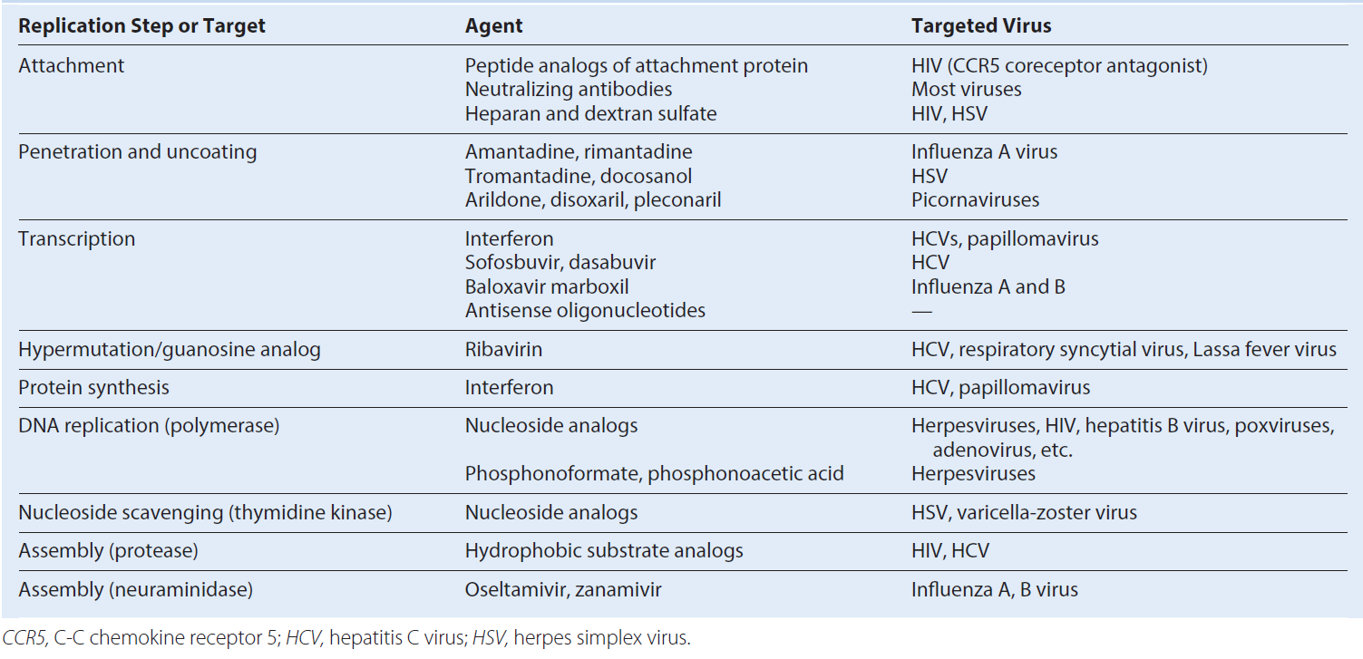
Some Antiviral Drug Therapies
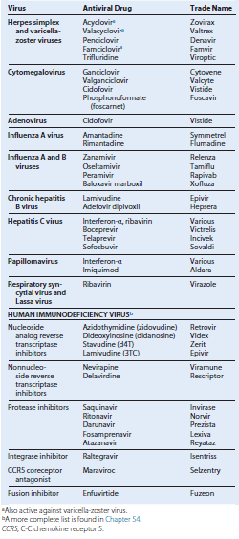

HERPESVIRUSES
Trigger Words
ᑏ HSV-1 and HSV-2: neurotropic, Cowdry type A inclusion bodies, syncytia, vesicle, Tzanck smear
ᑏᑏVZV: neurotropic, (V) all stages of lesions, (Z) lesions along single dermatome
ᑏᑏ EBV: lymphotropic: B cell, heterophile-positive mononucleosis, Burkitt lymphoma
ᑏᑏCMV: large cell and owl’s eye inclusion body, opportunistic, mononucleosis, congenital disease
ᑏᑏ and HHV7: lymphotropic, roseola
ᑏᑏHHV-8: Kaposi sarcoma, AIDS-related disease
ᑏᑏ B virus: monkey, fatal encephalopathy
Biology, Virulence, and Disease
- Large, enveloped, icosadeltahedral capsid, DNA genome
- Encodes polymerase and other proteins (HSV and VZV: thymidine kinase)
- Cell-mediated immune response essential for control
- Lytic, latent, recurrent infections; EBV and HHV-8 also associated with cancers
- HSV: oral/genital, encephalitis, keratoconjunctivitis, neonatal HSV; recurs from neurons
- VZV: pneumonia in adults, varicella, zoster; recurs from neurons
- EBV: heterophile-positive mononucleosis, B cell lymphomas; recurs from memory B cell
- CMV: opportunistic, congenital CMV, retinitis; recurs from monocyte and stem cell
- HHV-6: roseola
- HHV-8: Kaposi sarcoma
Epidemiology
ᑏᑏ Ubiquitous viruses
ᑏᑏ Transmitted by direct contact, bodily fluids
ᑏᑏVZV transmitted by aerosol and direct contact
Diagnosis
ᑏᑏCulture, immunologic tests (EBV serology), PCR and genome
analysis
Treatment, Prevention, and Control
ᑏᑏVaccines for varicella and zoster
ᑏᑏAntiviral drugs for HSV, VZV, and CMV CMV, Cytomegalovirus; EBV, Epstein-Barr virus; HHV, human herpesvirus; HSV, herpes simplex virus; PCR, polymerase chain reaction; VZV, varicella-zoster virus.
Unique Features of Herpesviruses
Have large, enveloped, icosadeltahedral capsids containing double-stranded DNA genomes.
Encode many proteins that manipulate the host cell and immune response.
Encode enzymes (DNA polymerase) that promote viral DNA replication and are good targets for antiviral drugs.
DNA replication and capsid assembly occurs in the nucleus.
Virus is released by exocytosis, by cell lysis, and through cell-to cell bridges.
Can cause lytic, persistent, latent, and (for Epstein-Barr virus) immortalizing infections.
Ubiquitous.
Cell-mediated immunity is required for control.
Properties Distinguishing the Herpesviruses
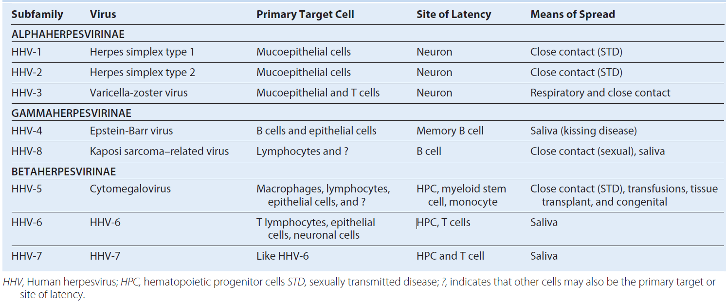
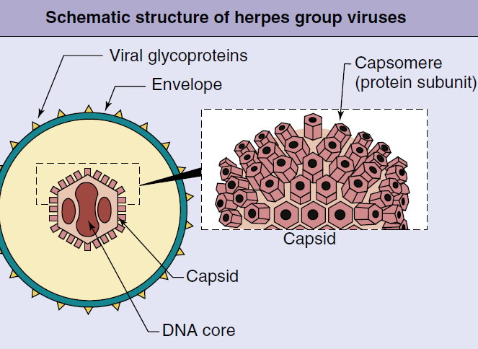
General structure of the herpesviruses. The DNA genome of the herpesvirus in the core is surrounded by an icosadeltahedral capsid and an envelope. Glycoproteins are inserted into the envelope. (A, From Cohen, J., Powderly, W.G., Opal, S.M., 2010. Infectious Diseases, third ed. Mosby, Philadelphia, PA.)
Disease Mechanisms for Herpes Simplex Viruses
Disease is initiated by direct contact and depends on infected tissue (e.g., oral, genital, brain).
Virus causes direct cytopathologic effects.
Virus avoids antibody by cell-to-cell spread and syncytia.
Virus establishes latency in neurons (hides from immune response).
Virus is reactivated from latency by stress, ultraviolet B light, or immune suppression.
Cell-mediated immunity is required for resolution, with a limited role for antibody.
Cell-mediated immunopathologic effects contribute to symptoms.
Triggers of Herpes Simplex Virus Recurrences
Ultraviolet B radiation (skiing, tanning)
Fever (hence the name “fever blister”)
Emotional stress (e.g., final examinations, big date)
Physical stress (irritation)
Menstruation
Foods: spicy, acidic, allergies
Immunosuppression:
Transient (stress related)
Chemotherapy, radiotherapy
Human immunodeficiency virus
Epidemiology of Herpes Simplex Virus
Disease/Viral Factors
Virus causes lifelong infection.
Recurrent disease is a source of contagion.
Virus may cause asymptomatic shedding.
Transmission
Virus is transmitted in saliva, in vaginal secretions, and by contact with lesion fluid (mixing and matching of mucous membranes).
Virus is transmitted orally and sexually and by placement into eyes and breaks in skin.
HSV-1 is generally transmitted orally; HSV-2 is generally transmitted sexually, but not exclusively.
Who Is at Risk?
Children and sexually active people are at risk for primary disease of HSV-1 and HSV-2, respectively.
Physicians, nurses, dentists, and others in contact with oral and genital secretions are at risk for infections of fingers (herpetic whitlow).
Immunocompromised people and neonates are at risk for disseminated life-threatening disease.
Geography/Season
Virus is found worldwide.
There is no seasonal incidence.
Modes of Control
Antiviral drugs are available for treatment and prophylaxis.
No vaccine is available.
Health care workers should wear gloves to prevent herpetic whitlow.
People with active genital lesions should refrain from intercourse until lesions are completely reepithelialized.
Disease syndromes of herpes simplex virus (HSV). HSV-1 and HSV-2 can infect the same tissues and cause similar diseases but have a predilection for the sites and diseases indicated.
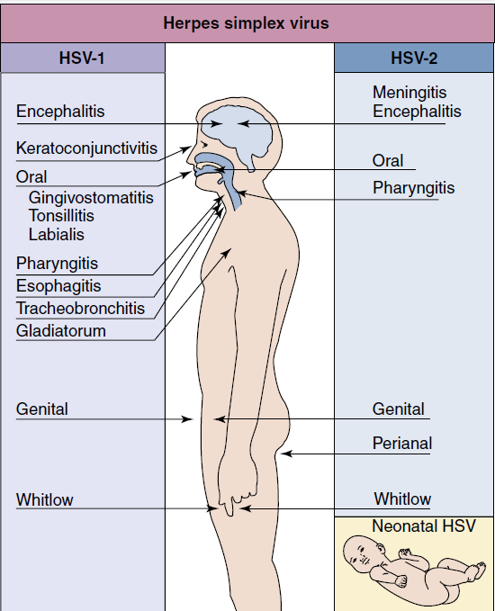

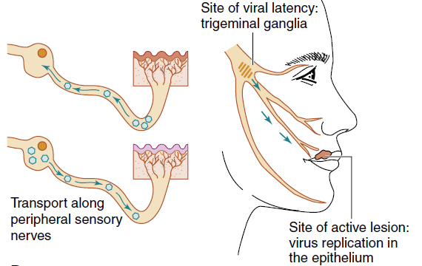
(A) Primary herpes gingivostomatitis. (B) Herpes simplex virus establishes latent infection and can recur from the trigeminal ganglia.

Clinical course of genital herpes infection. The time course and symptoms of primary and recurrent genital infection with herpes simplex virus type 2 are compared. Top, Primary infection; bottom, recurrent disease.
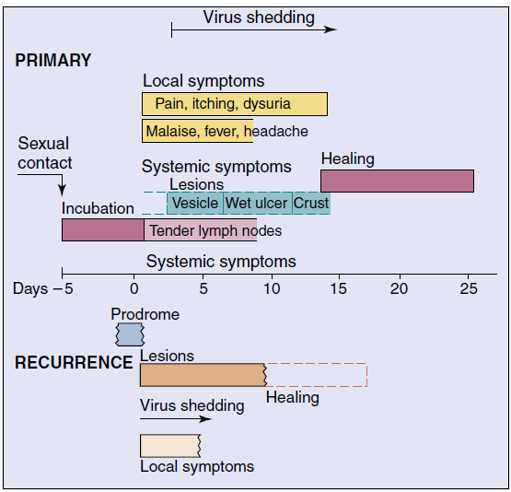

Laboratory Diagnosis of Herpes Simplex Virus Infections
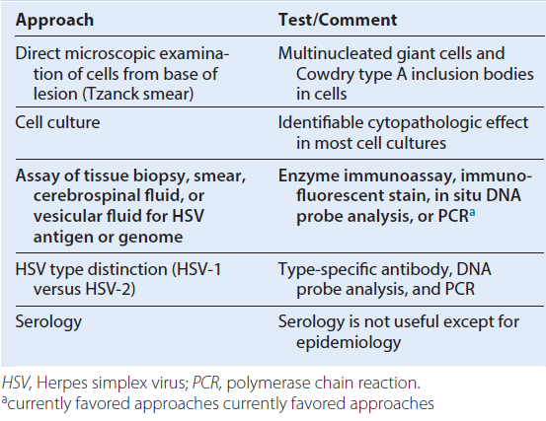
Antiviral Treatments for Herpesvirus Infections Herpes Simplex 1 and 2
Acyclovir
Penciclovir
Valacyclovir
Famciclovir
Trifluridine
Varicella-Zoster Virus
Acyclovir
Famciclovir
Valacyclovir
Varicella-zoster immune globulin
Zoster immune plasma
Live or adjuvanted subunit vaccine
Epstein-Barr Virus
None
Cytomegalovirus
Ganciclovira
Valganciclovira
Foscarneta
Cidofovira
aAlso inhibits herpes simplex and varicella-zoster viruses.
Mechanism of spread of varicella-zoster virus (VZV) within the body. VZV initially infects the respiratory tract and is spread to the reticuloendothelial system and T cells and then by cell-associated viremia to the skin.
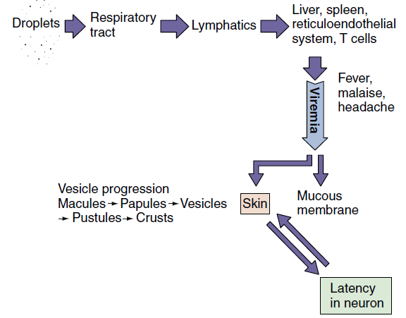
Time course of varicella (chickenpox). The course in young children, as presented in this figure, is generally shorter and less severe than that in adults.
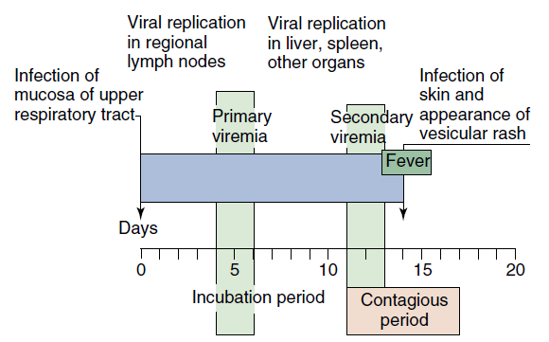
Disease Mechanisms of Varicella-Zoster Virus
Initial replication is in the respiratory tract.
Infects epithelial cells, fibroblasts, T cells, and neurons.
Can form syncytia and spread directly from cell to cell.
Spread by viremia in T cells to skin and causes lesions in successive crops.
Life-threatening pneumonia occurs in adults with primary infection caused by vigorous inflammatory response.
Can evade antibody clearance, and cell-mediated immune response is essential to control infection.
Disseminated life-threatening disease can occur in immunocompromised people.
Establishes latent infection of neurons, usually dorsal root and cranial nerve ganglia.
Herpes zoster is a recurrent disease; it results from virus replication along the entire dermatome.
Herpes zoster results from depression of cell-mediated immunity.
Epidemiology of Varicella-Zoster Virus
Disease/Viral Factors
Causes lifelong infection.
Recurrent disease is a source of contagion.
Transmission - Virus is transmitted mainly by respiratory droplets but also by direct contact.
Who Is at Risk?
Children (aged 5 to 9 years) experience mild classic disease.
Teenagers and adults are at risk for more severe disease with potential pneumonia.
Immunocompromised people and newborns are at risk for life-threatening pneumonia, encephalitis, and progressive disseminated varicella.
Elderly and immunocompromised people are at risk for recurrent disease (herpes zoster [shingles]) caused by a waning immune response.
Geography/Season
Virus is found worldwide.
There is no seasonal incidence.
Modes of Control
Antiviral drugs are available.
Varicella-zoster immunoglobulin is available for immunocompromised people and staff exposed to virus, as well as newborns of mothers showing symptoms within 5 days of birth.
Live vaccine (Oka strain) is available for children (varicella) and adults (zoster). Adjuvanted subunit vaccine also is available for zoster.
Markers of Epstein-Barr Virus Infection
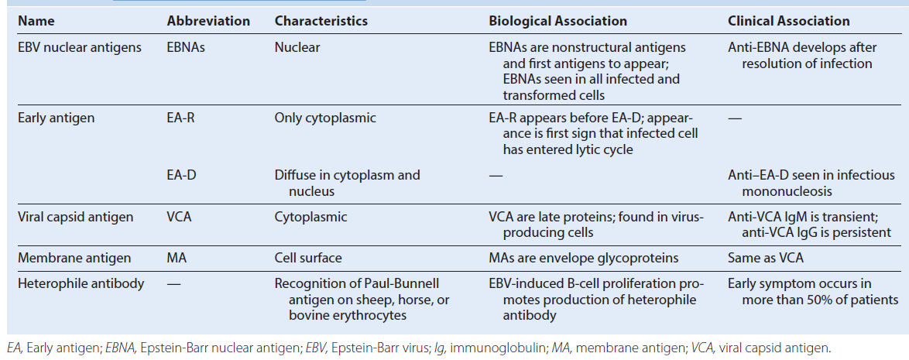

Progression of Epstein-Barr virus (EBV) infection. Infection may result in lytic, latent, or immortalizing infection, which can be distinguished on the basis of production of virus and expression of different viral proteins and antigens. T cells limit the outgrowth of the EBV-infected cells and maintain the latent infection. CD, Cluster of differentiation; EA, early antigen; EBER, Epstein-Barr–encoded RNA; EBNA, Epstein-Barr nuclear antigen; LMPs, latent membrane proteins; LP, latent protein; MA, membrane antigen; VCA, viral capsid antigen; WBCs, white blood cells; ZEBRA, peptide encoded by the Z gene region.
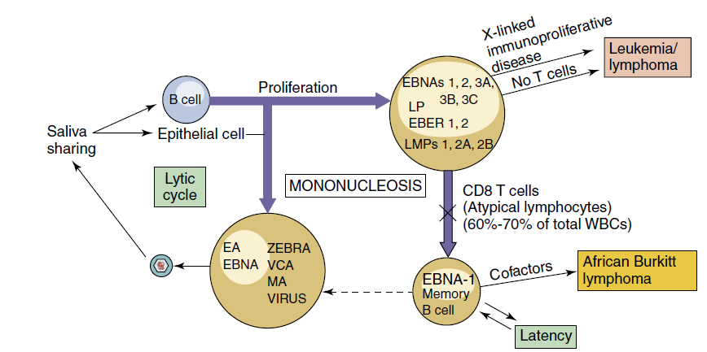

Disease Mechanisms of Epstein-Barr Virus
Virus in saliva initiates infection of oral epithelia and tonsillar B cells.
There is productive infection of epithelial cells and B cells.
Virus promotes growth of B cells (immortalizes).
T cells are stimulated by infected B cells; they kill and limit B-cell outgrowth. Tcells are required for controlling infection.
Antibody role is limited.
EBV establishes latency in memory B cells and is reactivated when the B cell is activated.
T-cell response (lymphocytosis) contributes to symptoms of infectious mononucleosis.
There is causative association with lymphoma in immunosuppressed people and African children living in malarial regions (African Burkitt lymphoma) and with nasopharyngeal carcinoma.
EBV-associated B-cell lymphomas may result from immunosuppression.
Pathogenesis of Epstein-Barr virus (EBV). EBV is acquired by close contact between persons through saliva and infects B cells. Resolution of the EBV infection and many of the symptoms of infectious mononucleosis result from activation of T cells in response to the infection.
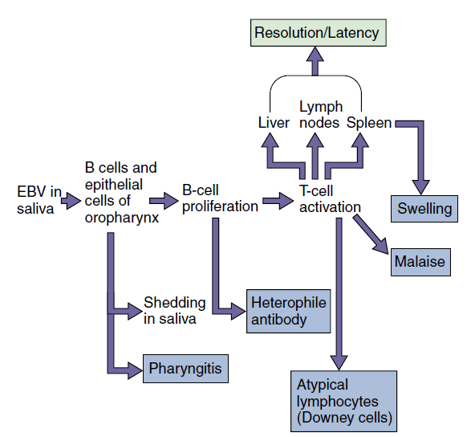

Epidemiology of Epstein-Barr Virus
Disease/Viral Factors
Virus causes lifelong infection.
Recurrent disease is primary source of contagion.
Virus may cause asymptomatic shedding.
Transmission
Transmission occurs via saliva, close oral contact (“kissing disease”), or sharing of items such as toothbrushes and cups.
Who Is at Risk?
Children experience asymptomatic disease or mild symptoms.
Teenagers and adults are at risk for infectious mononucleosis.
Immunocompromised people are at highest risk for life-threatening neoplastic disease.
Geography/Season
Infectious mononucleosis has worldwide distribution.
There is causative association with African Burkitt lymphoma in the malarial belt of Africa.
There is no seasonal incidence.
Modes of Control
There are no modes of control.
Clinical course of infectious mononucleosis and laboratory findings of those with the infection. Epstein-Barr virus infection may be asymptomatic or may produce the symptoms of mononucleosis.The incubation period can last as long as 2 months. EA, Early antigen; EBNA, Epstein-Barr nuclear antigen; Ig, immunoglobulin; VCA, viral capsid antigen.
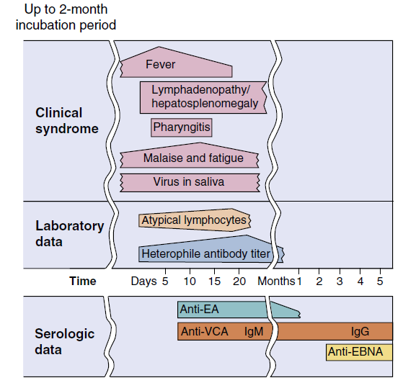
Diagnosis of Epstein-Barr Virus
1. Symptoms
a. Mild headache, fatigue, fever
b. Triad: lymphadenopathy, splenomegaly, exudative pharyngitis
c. Other: hepatitis, ampicillin-induced rash
2. Complete blood cell count
a. Hyperplasia
b. Atypical lymphocytes (Downey cells, T cells)
3. Heterophile antibody (transient)
4. EBV–antigen-specific antibody
5. Genome detection by PCR
EBV, Epstein-Barr virus; PCR, polymerase chain reaction.

Serologic Profile for Epstein-Barr Virus Infection
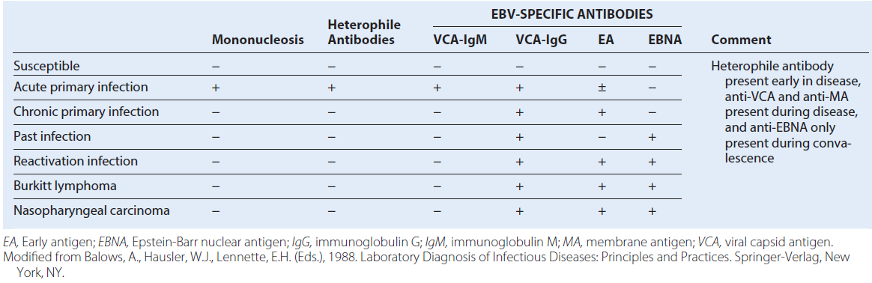
Disease Mechanisms of Cytomegalovirus
Acquired from blood, tissue, and most body secretions.
Causes productive infection of macrophages, epithelial cells, and other cells.
Establishes latency in hematopoietic stem cells and monocytes
Cell-mediated immunity is required for resolution and maintenance of latency and contributes to symptoms.
The role of antibody is limited.
Suppression of cell-mediated immunity allows recurrence and severe disease.
CMV generally causes subclinical infection.
Sources of Cytomegalovirus Infection
Neonate - Transplacental transmission, intrauterine infections, cervical secretions
Baby or child - Body secretions: breast milk, saliva, tears, urine
Adult - Sexual transmission (semen), blood transfusion, organ graft
Epidemiology of Disease/Viral Factors
Virus causes lifelong infection.
Recurrent disease is source of contagion.
Virus causes asymptomatic shedding.
Transmission
Transmission occurs via blood, organ transplants, and all secretions (urine, saliva, semen, cervical secretions, breast milk, and tears).
Virus is transmitted orally and sexually, in blood transfusions, in tissue transplants, in utero, at birth, and by nursing.
Who Is at Risk?
Babies
Babies of mothers who experience seroconversion during term are at high risk for congenital defects
Sexually active people
Blood and organ recipients
Burn victims
Immunocompromised people: symptomatic and recurrent disease
Geography/Season
Virus is found worldwide.
There is no seasonal incidence.
Modes of Control
Antiviral drugs are available for serious disease.
Screening potential blood and organ donors for cytomegalovirus reduces transmission of virus.
Cytomegalovirus Syndromes
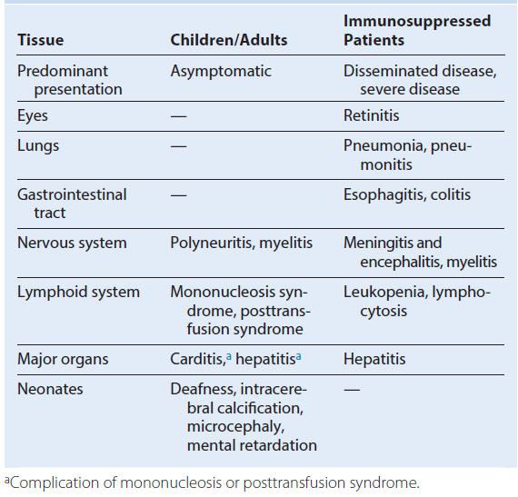
Outcomes of cytomegalovirus (CMV) infections. The outcome of CMV infection depends very heavily on the immune status of the patient. Ab, Antibody; AIDS, acquired immunodeficiency syndrome.
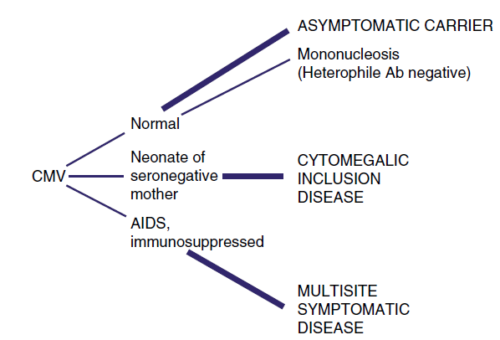

Laboratory Tests for Diagnosing Cytomegalovirus Infection
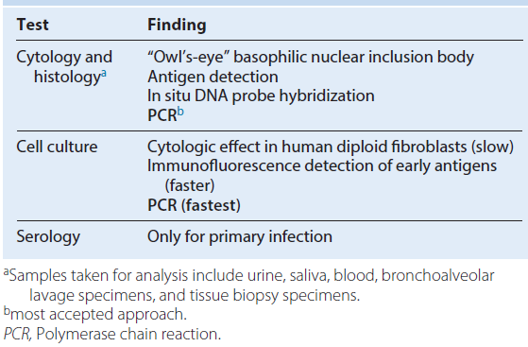
Clinical Summaries
Herpes Simplex Virus
Primary oral herpes: A 5-year-old boy has an ulcerative rash with vesicles around the mouth. Vesicles and ulcers are also present within the mouth. Results of a Tzanck smear show multinucleated giant cells (syncytia) and Cowdry type A inclusion bodies. The lesions resolve after 18 days.
Recurrent oral HSV: A 22-year-old medical student studying for examinations feels a twinge at the crimson border of his lip and 24 hours later has a single vesicular lesion at the site.
Recurrent genital HSV: A sexually active 32-year-old woman has a recurrence of ulcerative vaginal lesions with pain, itching, dysuria, and systemic symptoms 48 hours after being exposed to ultraviolet B light while skiing. The lesions resolve within 8 days. Results of a Papanicolaou smear show multinucleated giant cells (syncytia) and Cowdry type A inclusion bodies.
Encephalitis HSV: A patient has focal neurologic symptoms and seizures. Magnetic resonance imaging results show destruction of a temporal lobe. Erythrocytes are present in the cerebrospinal fluid, and polymerase chain reaction is positive for viral DNA.
Varicella-Zoster Virus
Varicella (chickenpox): A 5-year-old boy develops a fever and a maculopapular rash on his abdomen 14 days after meeting with his cousin, who also developed the rash. Successive crops of lesions appear for 3 to 5 days, and the rash spreads peripherally.
Zoster (shingles): A 65-year-old woman has a belt of vesicles along the thoracic dermatome and experiences severe pain localized to the region.
Epstein-Barr Virus
Infectious mononucleosis: A 23-year-old college student develops malaise, fatigue, fever, swollen glands, and pharyngitis. After empirical treatment with ampicillin for a sore throat, a rash appears. Heterophile antibody and atypical lymphocytes are detected from blood.
Cytomegalovirus
Congenital CMV disease: A neonate exhibits microcephaly, hepatosplenomegaly, and rash. Intracerebral calcification is noted on a radiograph. The mother had symptoms similar to mononucleosis during the third trimester of her pregnancy.
Human Herpesvirus 6
Roseola (exanthem subitum): A 4-year-old child experiences a rapid onset of high fever that lasts for 3 days and then suddenly returns to normal. Two days later, a maculopapular rash appears on the trunk and spreads to other parts of the body.
CMV, Cytomegalovirus; HSV, herpes simplex virus.
Time course of symptoms of exanthem subitum (roseola) caused by human herpesvirus 6 (HHV-6). Compare these symptoms and this time course with those of fifth disease, which is caused by parvovirus B19
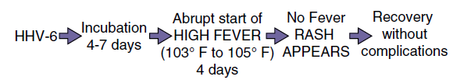

PICORNAVIRUSES
Trigger Words
Polio: flaccid paralysis, major and minor disease, fecal-oral
Coxsackievirus A: vesicular diseases, meningitis; coxsackievirus B (body): pleurodynia, myocarditis
Other echovirus and enteroviruses: like coxsackievirus and hepatitis A virus
Rhinoviruses: common cold, acid labile, does not replicate above 33° C
Biology, Virulence, and Disease
ᑏ Small size, icosahedral capsid, positive RNA genome with terminal protein
ᑏᑏGenome is sufficient for infection
ᑏᑏ Encodes RNA-dependent RNA polymerase, replicates in cytoplasm
Picornaviridae
Enterovirus
Poliovirus types 1, 2, and 3
Coxsackievirus A 24 types
Coxsackievirus B 6 types
Echovirusa 34 types
Parechovirus 16 types
Enterovirus 4
Hepatovirus
Hepatitis A virus
Rhinovirus: >100 types+
Cardiovirus
Aphthovirus
aEnteric, cytopathic, human, orphan + virus.
Unique Properties of Human Picornaviruses
Virion is a naked, small (25 to 30 nm), icosahedral capsid enclosing a single-stranded positive RNA genome.
Enteroviruses are resistant to pH 3 to pH 9, detergents, mild sewage treatment, and heat.
Rhinoviruses are labile at acidic pH; optimum growth temperature is 33° C.
Genome is an mRNA.
Naked genome is sufficient for infection.
Virus replicates in cytoplasm.
Viral RNA is translated into polyprotein, which is then cleaved into enzymatic and structural proteins.
Most viruses are cytolytic.
mRNA, Messenger ribonucleic acid.
Pathogenesis of enterovirus infection. The target tissue infected by the enterovirus determines the predominant disease caused by the virus. Coxsackie, Coxsackievirus; echo, echovirus; HAV, hepatitis A virus; polio, poliovirus.
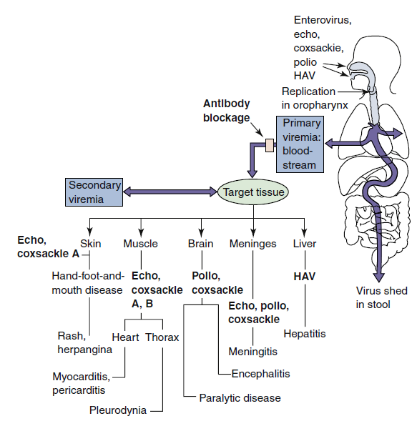

Disease Mechanisms of Picornaviruses
Enteroviruses enter via the oropharynx, intestinal mucosa, or upper respiratory tract and infect the underlying lymphatic tissue; rhinoviruses are restricted to the upper RT.
In the absence of serum antibody, enterovirus spreads by viremia to cells of a receptor-bearing target tissue.
Different picornaviruses bind to different receptors, many of which are members of the immunoglobulin superfamily (i.e.,intercellular adhesion molecule-1).
The infected target tissue determines the subsequent disease.
Viral, rather than immune, pathologic effects are usually responsible for causing dis.
The secretory antibody response is transitory but can prevent the initiation of infec.
Serum antibody blocks viremic spread to target tissue, preventing disease.
Enterovirus is shed in feces for long periods.
Infection is often asymptomatic or causes mild, flulike, or upper respiratory tract dis.
Epidemiology of Enterovirus Infections
Disease/Viral Factors
Nature of disease correlates with specific enterovirus, Severity of disease correlates with age of person, Infection often asymptomatic, with viral shedding, Virion resistant to environmental conditions (detergents, acid, drying, mild sewage treatment, heat)
Transmission
Fecal-oral route: poor hygiene, dirty diapers (especially in day-care settings), Ingestion via contaminated food and water, Contact with infected hands and fomites
Inhalation of infectious aerosols
Who Is at Risk?
Young children: at risk for polio (asymptomatic or mild disease), Older children and adults: at risk for polio (asymptomatic to paralytic disease), Newborns and neonates: at highest risk for serious coxsackievirus, echovirus, and enterovirus disease
Geography/Season- Viruses have worldwide distribution; wild-type polio virtually eradicated in most countries because of vaccination programs, Disease more common in summer
Modes of Control -For polio, live oral polio vaccine (trivalent OPV) or inactivated trivalent polio vaccine (IPV) is administered, For other enteroviruses, no vaccine; good hygiene limits spread
Transmission of enteroviruses. The capsid structure is resistant to mild sewage treatment, salt water, detergents, and temperature changes, allowing these viruses to be transmitted by fecal-oral routes, by fomites, and on hands.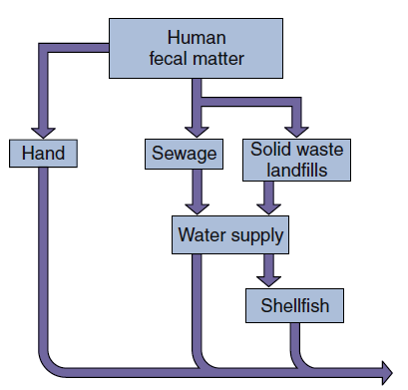

Incidence of polio in the United States. Killed (inactivated) polio vaccine (IPV) was introduced in 1955, and live oral polio vaccine (OPV) was introduced in 1961 and 1962. Wild-type polio has been eradicated in the United States.
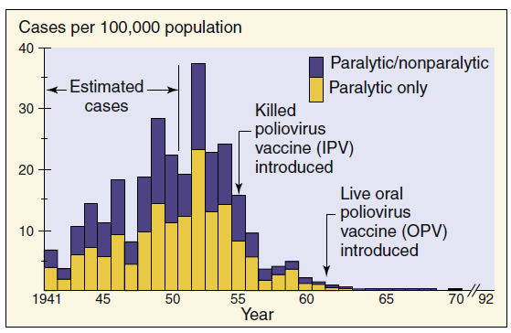

Summary of Clinical Syndromes Associated with Major Enterovirus Groups a
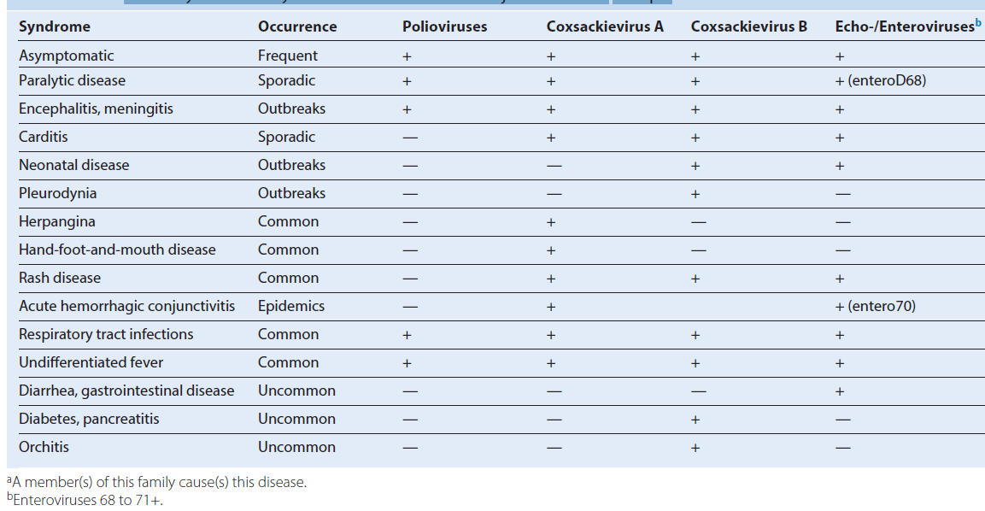

Progression of poliovirus infection. Infection may be asymptomatic or may progress to minor or major disease. CNS, Central nervous system.
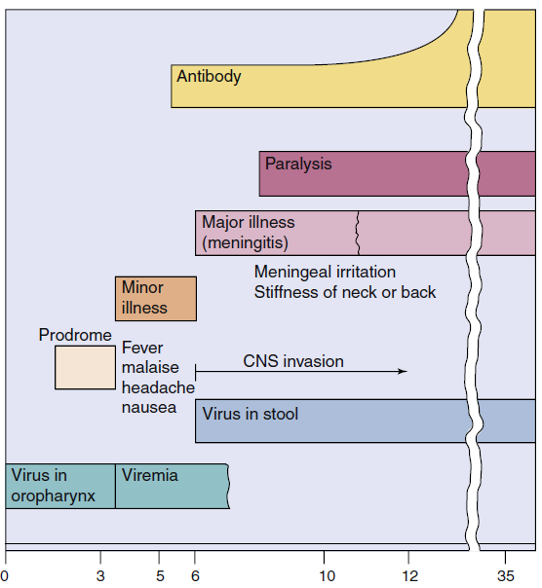

Advantages and Disadvantages of Polio Vaccines
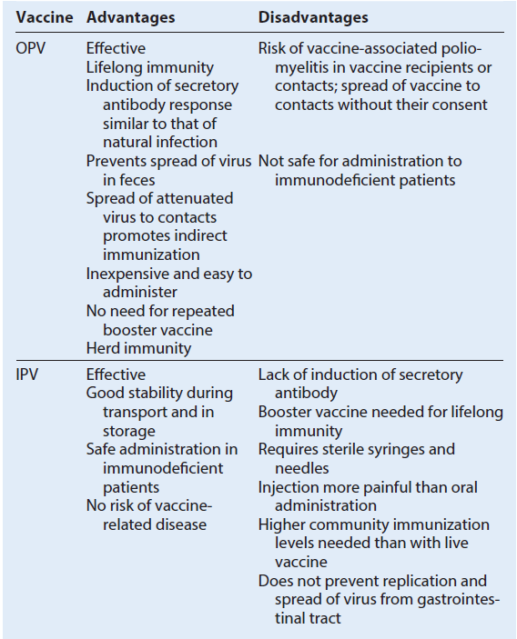
IPV, Inactive polio vaccine; OPV, live oral polio vaccine.

Serum and secretory antibody response to intramuscular inoculation of inactivated polio vaccine (IPV) and to oral live attenuated polio vaccine (OPV). Note the presence of secretory IgA induced by the OPV. Ig, Immunoglobulin.
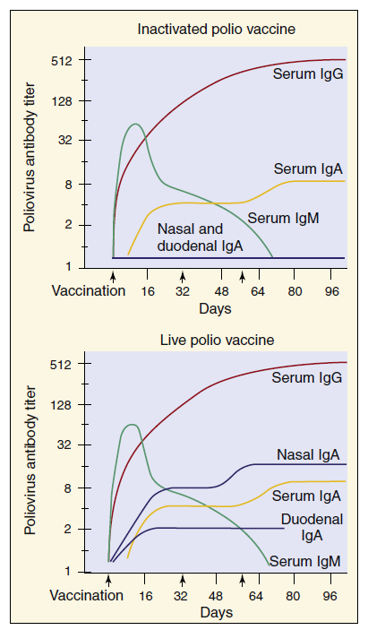

Clinical Summaries
Poliovirus
Polio: A 12-year-old girl from Nigeria has headache, fever, nausea, and stiff neck. Symptoms improve and then recur several days later, with weakness and paralysis of her legs. She has no history of polio immunization.
Coxsackievirus A
Herpangina: Vesicular lesions on the tongue and roof of the mouth of a 7-year-old patient accompany fever, sore throat, and pain on swallowing.
Coxsackievirus B (B for body)
Pleurodynia: A 13-year-old boy has fever and severe chest pain with headache, fatigue, and aching muscles lasting for 4 days.
Coxsackievirus or Echovirus
Aseptic meningitis: A 7-month-old infant with fever and rash appears listless, with a stiff neck. A sample of his cerebrospinal fluid contains lymphocytes but has normal glucose and no bacteria. Full recovery occurs within 1 week.

RHABDOVIRUSES
Trigger Words-Mad dog, hydrophobia, salivation, bullet-shaped virion, Negri bodies

Biology, Virulence, and Disease
ᑏ Medium size, bullet shaped, enveloped, (−) RNA genome
ᑏᑏ Encodes RNA-dependent RNA polymerase, replicates in cytoplasm
ᑏᑏAntibody can block disease
ᑏᑏVirus spreads along neurons to salivary glands and brain
ᑏᑏAntibody produced after virus reaches brain
ᑏᑏ Incubation period depends on proximity of bite to CNS and infectious dose
Epidemiology
ᑏᑏZoonosis
ᑏᑏ Reservoir in skunks, raccoons, foxes, badgers, bats (aerosols)
Diagnosis
ᑏᑏ RT-PCR, antigen detection in biopsy, presence of Negri bodies in infected cells
Treatment, Prevention, and Control
ᑏᑏ Immunization with killed vaccine after bite and antirabies immunoglobulin
ᑏᑏ Prophylaxis if job-related risk
ᑏᑏ Inactivated vaccine for pets
ᑏᑏVaccinia virus hybrid vaccine for wild animals
Unique Features of Rhabdoviruses
Bullet-shaped, enveloped, negative-sense, single-stranded RNA viruses that encode five proteins.
Prototype for replication of negative-strand enveloped viruses.
Replication in cytoplasm.
Disease Mechanisms of Rabies Virus
Rabies is usually transmitted in saliva and acquired from the bite of a rabid animal.
Rabies virus is not very cytolytic and seems to remain cell associated except in salivary gland.
Virus replicates in the muscle at the site of the bite, with minimal or no symptoms (incubation phase).
The length of the incubation phase is determined by the infectious dose and the proximity of the infection site to the CNS and brain.
After weeks to months, the virus infects the peripheral nerves and travels up the CNS to the brain (prodrome phase).
Infection of the brain causes classic symptoms, coma, and death (neurologic phase).
During the neurologic phase, the virus spreads to the glands, skin, and other body parts, including the salivary glands.
Rabies infection does not elicit an antibody response until the late stages of the disease, when the virus has spread from the CNS to other sites.
Salivary glands produce and release large amounts of virus and is the major source of contagion.
Administration of antibody can block progression of the virus and disease if given early enough.
The long incubation period allows active immunization as a postexposure treatment.
CNS, Central nervous sy stem.
Pathogenesis of rabies virus infection. Numbered steps describe the sequence of events. (Modified from Belshe, R.B., 1991. Textbook
of Human Virology, second ed. Mosby, St Louis, MO.)
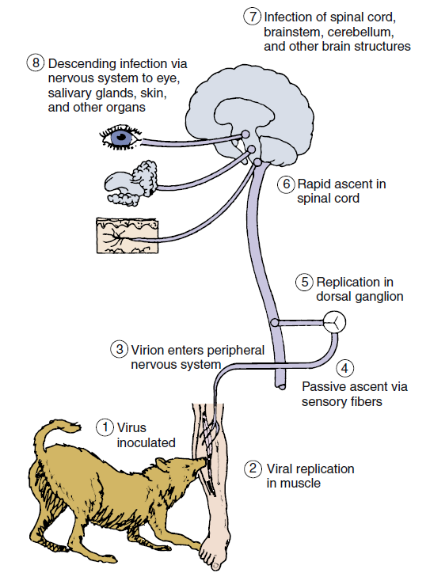

Epidemiology of Rabies Virus
Disease/Viral Factors
Virus-induced aggressive behavior in animals promotes virus spread.
Production of virus by salivary gland transmits virus in bite.
Disease has long, asymptomatic incubation period.
Transmission
Zoonosis
Reservoir: wild animals.
Vector: wild animals and unvaccinated dogs and cats.
Source of virus
Major: saliva in bite of rabid animal (including bats).
Minor: aerosols in bat caves containing rabid bats.
Rare: transplant of contaminated cornea or organ.
Who Is at Risk?
Veterinarians and animal handlers.
Person bitten by a rabid animal.
Inhabitants of countries with no pet vaccination program.
Geography/Season
Virus found worldwide, except in some island nations.
No seasonal incidence.
Modes of Control
Vaccination program is available for pets.
Vaccination is available for at-risk personnel.
Vaccination programs have been implemented to control rabies in forest mammals.
Clinical Summary
Rabies: A 3-year-old girl was found to have a bat flying in her bedroom. The bat apparently was there all night. There was no evidence of any bite wound or contact, and the bat was caught and released. Three weeks later, the child developed a change in behavior, becoming irritable and agitated. This state quickly progressed to confusion, uncontrollable thrashing about, and inability to handle her secretions. She eventually became comatose and died from respiratory arrest.

Progression of Rabies Disease

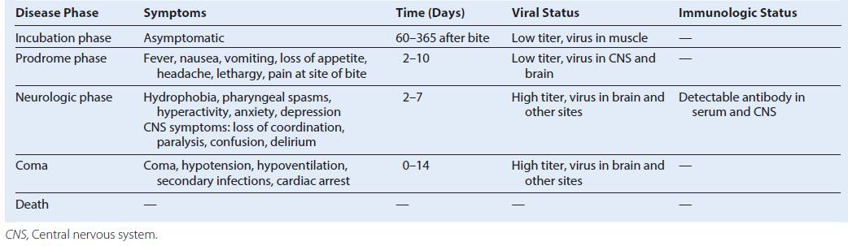

Patterns of alphavirus and flavivirus transmission. Birds and small mammals are the hosts that maintain and amplify an arbovirus, which is spread by the insect vector during a blood meal. A double arrow indicates a cycle of replication in both host (including man) and vector. “Dead-end” infections with no transmission of the virus back to the vector are indicated by the single arrow. EEEV, Eastern equine encephalitis virus; VEEV, Venezuelan equine encephalitis virus; WEEV, western equine encephalitis virus.
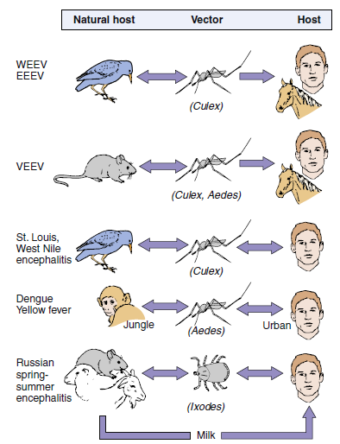

Arboviruses
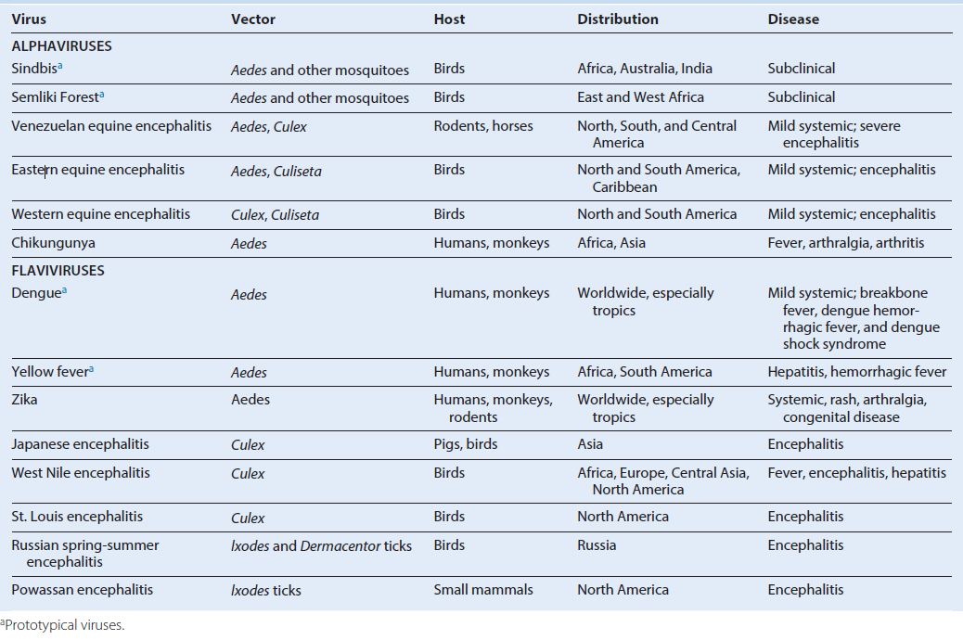

TOGAVIRUSES
Trigger Words
Arboviruses: mosquito, encephalitis
Rubella: German measles, congenital disease, rash, vaccine

Biology, Virulence, and Disease
ᑏ Small size, envelope surrounds icosahedral nucleocapsid, (+) RNA genome
ᑏᑏ Encodes RNA-dependent RNA polymerase, replicates in cytoplasm
ᑏᑏ Early and late mRNA and proteins produced
ᑏᑏVirus spreads in blood to target tissues, including neurons and brain
ᑏᑏ Antibody can block viremia and disease
ᑏᑏ Prodrome of flulike symptoms caused by interferon and cytokine response
ᑏᑏ Arboviruses: equine encephalitis viruses (WEE, EEE, VEE)
ᑏᑏ Rubella: benign childhood rash, swollen glands. Adult complications include
arthritis, encephalitis. Congenital infection: teratogenic, cataracts, deafness, microcephaly, etc.
Epidemiology
ᑏᑏ Arboviruses: zoonosis, reservoir in birds, vectors are Aedes and Culex mosquitoes
ᑏᑏ Rubella: aerosol spread, only infects humans, unvaccinated individuals at
risk, fetus at high risk
Diagnosis
ᑏᑏ RT-PCR, ELISA
Treatment, Prevention, and Control
ᑏᑏ Arboviruses: mosquito control
ᑏᑏ Live attenuated rubella vaccine at 1 year of age in MMR; booster at 4 to 6 years
FLAVIVIRUSES
Trigger Words
Arboviruses: mosquito, encephalitis, hemorrhagic diseases
Hepatitis C virus
Biology, Virulence, and Disease
ᑏᑏ Small size, envelope surrounds icosahedral nucleocapsid, (+) RNA genome
ᑏᑏ Encodes RNA-dependent RNA polymerase, replicates in cytoplasm
ᑏᑏ Neutralizing antibody can block disease
ᑏᑏ Nonneutralizing antibody promotes dengue virus infection
ᑏᑏ Cross-reactive antibodies produced against different flaviviruses
ᑏᑏ Virus spreads in blood to target tissues:for encephalitis viruses neurons and brain; for hemorrhagic viruses vasculature, liver, organs
ᑏᑏ Prodrome of flulike symptoms caused by interferon and cytokine response
ᑏᑏ Arboviruses
ᑏᑏ Encephalitis viruses: St. Louis, West Nile, Japanese encephalitis viruses
ᑏᑏ Hemorrhagic disease:
Yellow fever: jaundice, black vomit
Dengue: hemorrhagic fever, breakbone fever, dengue shock syndrome
Epidemiology
ᑏᑏ Endemic to habitat of mosquito
ᑏᑏ Arboviruses: zoonosis, reservoir in birds, vectors are Aedes or Culex mosquitoes
Diagnosis
ᑏᑏ RT-PCR, ELISA
Treatment, Prevention, and Control
ᑏᑏ Arboviruses: mosquito control
ᑏᑏ Yellow fever virus: attenuated live vaccine
Unique Features of Togaviruses and Flaviviruses
Viruses have enveloped, single-stranded, positive-sense RNA.
Togavirus replication includes early (nonstructural) and late (structural) protein synthesis.
Togaviruses replicate in the cytoplasm and bud at plasma membranes.
Flaviviruses replicate in the cytoplasm and bud at intracellular membranes.
Togaviruses and Flaviviruses
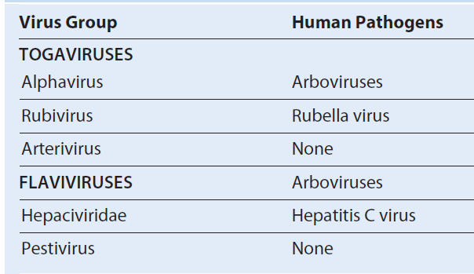

Alphavirus morphology. (B) Cross section of alpha-togavirus. The envelope is tightly associated with the capsid. (C) Cross section of flavivirus. The envelope protein surrounds the membrane envelope, which encloses an icosahedral nucleocapsid. RNA, Ribonucleic acid. (A, From Fuller, S.D., 1987. The T = 4 envelope of Sindbis virus is organized by interactions with a complementary T = 3 capsid. Cell)
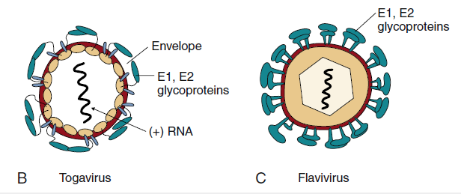

Disease Mechanisms of Togaviruses and Flaviviruses
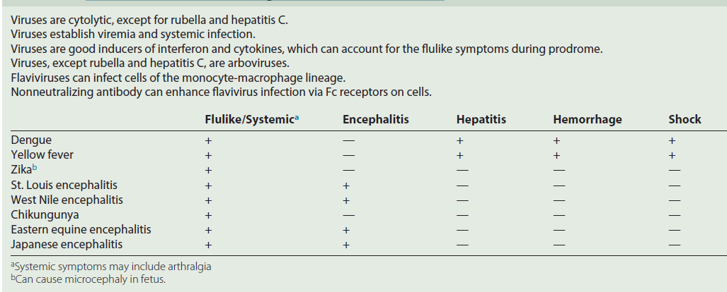

Disease syndromes of the alphaviruses and flaviviruses. Primary viremia may be associated with mild systemic disease. Most infections are limited to this. If sufficient virus is produced during the secondary viremia to reach critical target tissues, then severe systemic disease or encephalitis may result. If antibody is present (X), viremia is blocked. For dengue virus, rechallenge with another strain can result in severe dengue hemorrhagic fever (DHF), which can cause dengue shock syndrome (DSS) because of the loss of fluids rom the vasculature.
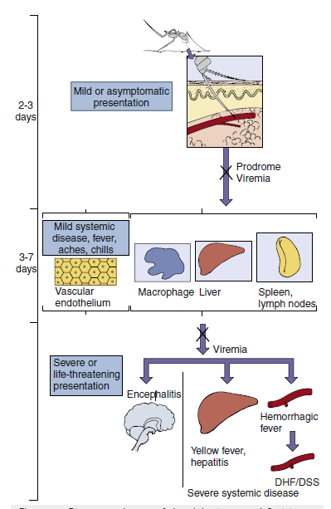

Epidemiology of Alphavirus and Flavivirus Infection
Disease/Viral Factors
Enveloped virus must stay wet and can be inactivated by drying, soap, and detergents.
Virus can infect mammals, birds, reptiles, and insects.
Asymptomatic or nonspecific (flulike fever or chills), encephalitis, hemorrhagic fever, or arthralgia.
Transmission
Specific arthropods characteristic of each virus (zoonosis: arbovirus).
Who Is at Risk?
People who enter ecologic niche of arthropods infected by arboviruses.
Geography/Season
Endemic regions for each arbovirus are determined by habitat of mosquito or other vector.
Aedes mosquito, which carries dengue and yellow fever, is found in urban areas and in pools of water.
Culex mosquito, which carries St. Louis encephalitis and West Nile encephalitis viruses, is found in forest and urban areas.
Disease is more common in summer.
Modes of Control
Mosquito breeding sites and mosquitoes should be eliminated. Live attenuated yellow fever virus and inactivated Japanese encephalitis virus vaccines. Spread of rubella virus within the host. Rubella enters and infects the nasopharynx and lung and then spreads to the lymph nodes and monocyte-macrophage system. The resulting viremia spreads the virus to other tissues and the skin. Circulating antibody can block the transfer of virus at the indicated points (X). In an immunologically deficient pregnant woman, the virus can infect the placenta and spread to the fetus.
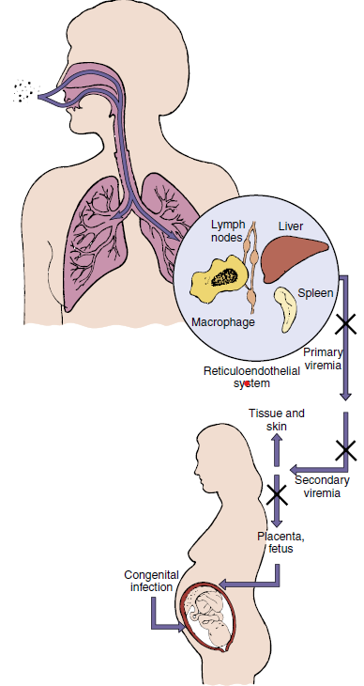
Epidemiology of Rubella Virus
Disease/Viral Factors
Rubella infects only humans.
Virus can cause asymptomatic disease.
There is one serotype.
Transmission
Respiratory route
Who Is at Risk?
Children: mild exanthematous disease.
Adults: more severe disease with arthritis or arthralgia.
Fetus <20 weeks: congenital defects.
Modes of Control-Live attenuated vaccine administered as part of the measles mumps-rubella vaccine.
Time course of rubella disease. Rubella production in the pharynx precedes the appearance of symptoms and continues throughout the course of the disease. The onset of lymphadenopathy coincides with the viremia. Fever and rash occur later. The person is infectious as long as the virus is produced in the pharynx.
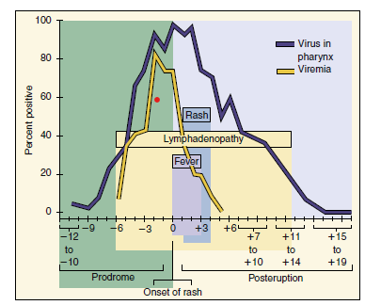

Prominent Clinical Findings in Congenital Rubella Syndrome
Cataracts and other ocular defects
Heart defects
Deafness
Intrauterine growth retardation
Failure to thrive
Mortality within the first year
Microcephaly
Mental retardation
Clinical Summaries
West Nile encephalitis: During August, a 70-year-old man from a swampy area of Louisiana developed fever, headache, muscle weakness, nausea, and vomiting. He had difficulty answering questions. He progressed into a coma. Magnetic resonance imaging results show no specific localization of lesions (unlike in herpes simplex virus encephalitis). His disease progressed to respiratory failure and death. His 25-year-old niece, living next door, complained of sudden onset of fever (39° C [102.2° F]), headache, and myalgias, with nausea and vomiting lasting 4 days.
Yellow fever: A 42-year-old man had fever (103° F), headache, vomiting, and backache that started 3 days after returning from a trip to Central America. He appeared normal for a short time, but then his gums started to bleed; he had bloody urine and vomited blood; and he developed petechiae, jaundice, and a slower and weakened pulse. He started to improve 10 days after the onset of disease.
Rubella: A 6-year-old girl from Romania developed a faint rash on her face, accompanied by mild fever and lymphadenopathy.
Over the next 3 days, the rash progressed to other parts of the body. She had no history of rubella immunization.
BUNYAVIRUSES
Trigger Words
Arboviruses: mosquito, encephalitis
Hantaviruses: rodent, hemorrhagic disease
Biology, Virulence, and Disease
ᑏ Medium size, enveloped, (−) segmented RNA genome
ᑏᑏ Encodes RNA-dependent RNA polymerase, replicates in cytoplasm
ᑏᑏ Antibody can block disease
ᑏᑏ Virus spreads in blood to tissues, neurons, and brain
ᑏᑏ Prodrome of flulike symptoms caused by interferon and cytokine response
ᑏᑏ Encephalitis: La Crosse, California encephalitis
ᑏᑏ Hantaviruses: pulmonary syndrome
Epidemiology
ᑏᑏ Encephalitis viruses: zoonosis, reservoir in birds, vector is the mosquito
ᑏᑏHantavirus: inhalation of aerosols from rodent urine or feces
Diagnosis
ᑏᑏ RT-PCR, ELISA
Treatment, Prevention, and Control
ᑏᑏArboviruses: mosquito control
ᑏᑏHantaviruses: rodent control
ARENAVIRUSES
Trigger Words
ᑏᑏ Ribosomes in virion, rodent, Lassa fever virus, hemorrhagic disease, LCM virus, meningitis
Biology, Virulence, and Disease
ᑏᑏMedium size, enveloped, (−) segmented RNA genome
ᑏᑏNonfunctional ribosomes in virion
ᑏᑏ Encodes RNA-dependent RNA polymerase, replicates in cytoplasm
ᑏᑏAntibody can block disease
ᑏᑏVirus spreads in blood to tissues, neurons, and brain
ᑏᑏ Prodrome of flulike symptoms caused by interferon and cytokine response
ᑏᑏ LCM virus: meningitis
ᑏᑏ Lassa fever: hemorrhagic fever
Epidemiology
ᑏᑏ Inhalation of aerosols from rodent urine or feces
ᑏᑏ LCM virus: worldwide
ᑏᑏ Lassa fever: Africa
Diagnosis
ᑏᑏ RT-PCR, ELISA
Treatment, Prevention, and Control
ᑏᑏ Rodent control
Unique Features of Bunyaviruses
There are at least 200 related viruses in five genera that share a common morphology and basic components.
Virion is enveloped with three (L, M, S) negative-sense ribonucleic acid nucleocapsids but no matrix proteins.
Virus replicates in the cytoplasm.
Virus can infect humans, animals, and arthropods.
Virus in an arthropod can be transmitted to its eggs.
Notable Bunyaviridae Generaa
Disease Mechanisms for Bunyaviruses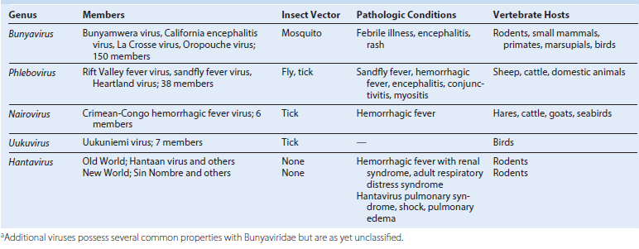

Virus is acquired from an arthropod bite (e.g., mosquito).
For hantaviruses, the virus is acquired from rodent urine or feces.
Initial viremia causes flulike symptoms.
Establishment of secondary viremia may allow virus access to specific target tissues that define the disease, including the central nervous system, organs, and vascular endothelium.
Viral and immunopathogenesis causes tissue disruption.
Antibody is important in controlling viremia; interferon and cell-mediated immunity may prevent the outgrowth of infection and contribute to disease.
Epidemiology of Bunyavirus Infections
Disease/Viral Factors
Arboviruses able to replicate in mammalian and arthropod cells.
Arboviruses able to pass into ovary and infect arthropod eggs, allowing virus to survive during winter.
Transmission
Arboviruses, via arthropod’s blood meal; California encephalitis group, Aedes mosquito;
Aedes mosquitoes are aggressive daytime feeders and live in forests.
Aedes mosquitoes lay eggs in small pools of water trapped in places such as trees and tires.
Hantavirus: transmitted in aerosols from rodent urine and feces and by close contact with infected rodents.
Who Is at Risk?
People in habitat of arthropod or rodent vector.
California encephalitis group: campers, forest rangers, woodsmen.
Geography/Season
Disease incidence correlates with distribution of vector.
Disease more common in summer.
Modes of Control
Elimination of vector or vector’s habitat.
Avoidance of vector’s habitat.
Clinical Summary
Lassa fever: Approximately 10 days after returning from a trip to visit family in Nigeria, a 47-year-old man developed flulike symptoms with a higher than expected fever and malaise. The disease got progressively worse, and after 3 days, the patient developed abdominal pain, nausea, vomiting, diarrhea, pharyngitis, bleeding gums, and began vomiting blood. He developed shock and then died.
Arboviruses and Zoonoses
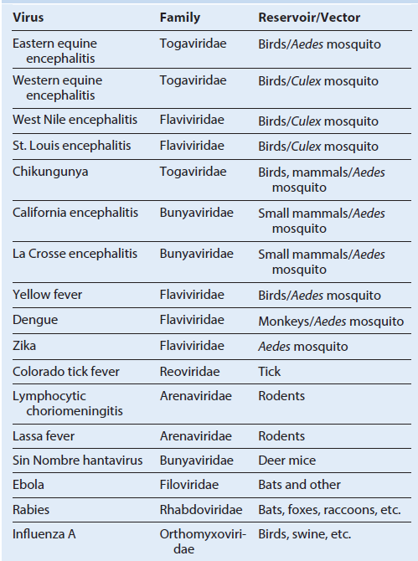

REOVIRUSES
Trigger Words
Fecal-oral, infantile diarrhea, doubledouble (capsid and double-stranded segmented RNA genome), oral vaccine
Biology, Virulence, and Disease
ᑏ Medium size, double capsid, doublestranded segmented RNA genome
ᑏᑏCapsid resistant to inactivation
ᑏᑏ Encodes RNA-dependent RNA polymerase, replicates in cytoplasm
ᑏᑏ Each segment encodes one or two proteins
ᑏᑏMixed infection results in genetic mixing of segments: reassortment
ᑏᑏ Rotavirus induces cholera-type diarrhea
ᑏᑏOne of the most serious causes of diarrhea in young children
ᑏᑏColorado tick fever, zoonosis, dengue-like disease with rash
Epidemiology
ᑏᑏ Rotavirus
ᑏᑏWorldwide and ubiquitous, occurs year round
ᑏᑏ Fecal-oral spread, very contagious, infants at risk for serious disease
Diagnosis
ᑏᑏ ELISA for virus in stool
Treatment, Prevention, and Control
ᑏᑏ Treatment: supportive rehydration
ᑏᑏ Prevention: oral live vaccines administered at 2, 4, and 6 months of age
ᑏᑏControl: handwashing and good Hygiene
Reoviridae Responsible for Human Disease
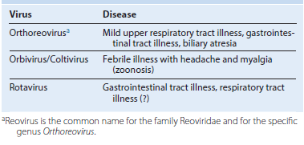
Unique Features of Reoviridae
Double-layered or triple-layered capsid virion (60 to 80 nm) has icosahedral symmetry containing 10 to 12 (depending on the virus) unique double-stranded genomic segments (double:double virus).
Virion is resistant to environmental and gastrointestinal conditions (e.g., detergents, acidic pH, drying).
Rotavirus and orthoreovirus virions are activated by mild proteolysis to intermediate/infectious subviral particles, increasing their infectivity.
Inner capsid contains a complete transcription system, including RNA-dependent RNA polymerase and enzymes for 5′ capping and polyadenylate addition.
Viral replication occurs in the cytoplasm. Double-stranded RNA remains in the inner core.
Inner capsid aggregates around (+) RNA and transcribes (−) RNA in the cytoplasm.
Rotavirus-filled inner capsids bud into the endoplasmic reticulum, acquiring its outer capsid and a membrane, which is then lost.
Virus is released by cell lysis.
Schematic of rotavirus. Descriptions of the viral proteins. dsRNA, Double-stranded ribonucleic acid.
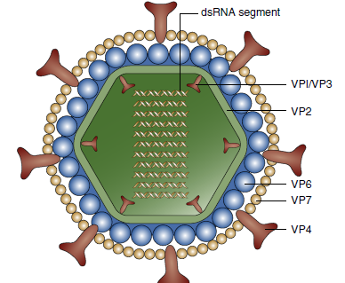
Functions of Rotavirus Gene Products
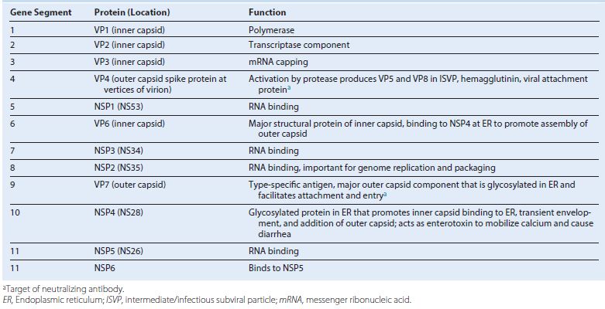

Replication of rotavirus. Rotavirus virions can be activated by protease (e.g., in the gastrointestinal tract) to produce an intermediate/infectious subviral particle (ISVP). The virion or ISVP binds, penetrates the cell, and loses its outer capsid. The inner capsid contains the enzymes for messenger ribonucleic acid (mRNA) transcription using the (±) strand as a template. Some mRNA segments are transcribed early, and others are transcribed later. Enzymes in the virion cores attach 5′-methyl capped guanosine (*G) and 3′-polyadenylate sequence (poly A [AAA]) to mRNA. (+) RNA is mRNA and is also enclosed into inner capsids as a template to replicate the ± segmented genome. VP7 and NSP4 are synthesized as glycoproteins and expressed in the endoplasmic reticulum. The capsids aggregate and “dock” onto the NSP4 protein in the endoplasmic reticulum, acquiring VP7 and its outer capsid and an envelope. The virus loses the envelope and leaves the cell on cell lysis.
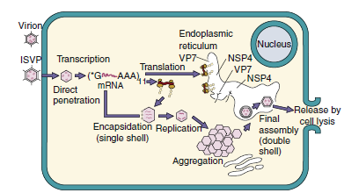

Functions of Reovirus Gene Products
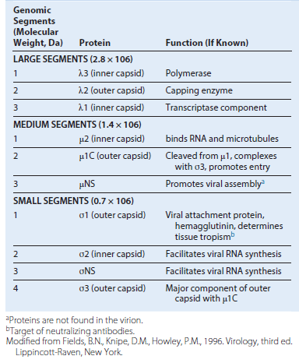
Disease Mechanisms of Rotavirus
Virus is spread primarily by the fecal-oral route.
Cytolytic and toxin-like action on the intestinal epithelium causes loss of electrolytes and prevents reabsorption of water.
Disease can be significant in infants <24 months, but can be asymptomatic in adults.
Large amounts of virus are released during the diarrheal phase.
Epidemiology of Rotavirus. Disease/Viral Factors
Capsid virus is resistant to environmental and gastrointestinal conditions.
Large amounts of virus are released in fecal matter. Asymptomatic infection can result in release of virus.
Transmission - Virus is transmitted in fecal matter, especially in day-care settings.
Respiratory transmission may be possible.
Who Is at Risk?
Rotavirus Group A
Infants <24 months of age: at risk for infantile gastroenteritis with potential dehydration. Older children and adults: at risk for mild diarrhea. Undernourished people in underdeveloped countries: at risk for diarrhea, dehydration, and death.
Rotavirus Group B (Adult Diarrhea Rotavirus)- Infants, older children, and adults in China: at risk for severe gastroenteritis.
Geography/Season - Virus is found worldwide.
Disease is more common in autumn, winter, and spring.
Modes of Control-Handwashing and isolation of known cases are modes of control.
Live vaccines use attenuated human or bovine reassorted rotavirus.

